Выполненные тесты присылать на почту rubtsova.ins@mail.ru до 28.12.2020 г.

CHECK-TEST

Words and sentences
1 We gave .............................. a meal.
- at the visitors b) for the visitors c) the visitors d) to the visitors

Verbs
2 I'm busy at the moment. ......................................on the computer.
- I work b) I'm work c) I'm working d) I working

3 My friend ............................... the answer to the question.
- is know b) know c) knowing d) knows

4 I think I'll buy these shoes ......................................really well.
- They fit b) They have fit c) They're fitting d) They were fitting

5 Where ................................... the car?
- did you park b) did you parked c) parked you d) you parked

6 At nine o'clock yesterday morning we ....................... for the bus.
- wait b) waiting c) was waiting d) were waiting

7 When I looked round the door, the baby ........ ..........quietly.
- is sleeping b) slept c) was sleeping d) were sleeping

8 Here's my report ..................................... it at last.
- I finish b) I finished c) I'm finished d) I've finished

9 I've ........ made some coffee. It's in the kitchen.
- ever b) just c) never d) yet

10 We .................................... to Ireland for our holidays last year.
- goes b) going c) have gone d) went

11 Robert... ... ill for three weeks. He's still in hospital.
- had been b) has been c) is d) was

12 My arms are aching now because ........ since two o'clock.
- I'm swimming b) I swam c) I swim d) I've been swimming

13 I'm very tired. over four hundred miles today.
- I drive b) I'm driving c) I've been driving d) I've driven

14 When Martin the car, he took it out for a drive.
- had repaired b) has repaired c) repaired d) was repairing

15 Janet was out of breath because ...
- she'd been running b) she did run c) she's been running d) she's run

16 Don't worry. I be here to help you.
- not b) shall c) willn't d) won't

17 Our friends………..meet us at the airport tonight.
- are b) are going to c) go to d) will be to

18 a party next Saturday. We've sent out the invitations.
- We had b) We have c) We'll have d) We're having

19 I'll tell Anna all the news when.................................. her.
- I'll see b) I'm going to see c) I see d) I shall see

20 At this time tomorrow...................................over the Atlantic.
- we flying b) we'll be flying c) we'll fly d) we to fly

21 Where's Robert? ........ ........ a shower?
- Does he have b) Has he c) Has he got d) Is he having

22 I .....................like that coat. It's really nice.
- am b) do c) very d) yes

Questions, negatives and answers
23 What's the weather like in Canada? How often................................. there?
- does it snow b) does it snows c) snow it d) snows it

24 Which team .................................. the game?
- did it win b) did they win c) won d) won it

25 What did you leave the meeting early ...............................? ~ I didn't feel very well.
- away b) because c) for d) like

26 Unfortunately the driver.................................. the red light.
- didn't saw b) didn't see c) no saw d) saw not

27 You haven't eaten your pudding...................................it?
- Are you no want b) Do you no want c) Don't want you d) Don't you want

28 I really enjoyed the disco. It was great,.............................. ?
- is it b) isn't it c) was it d) wasn't it

29 Are we going the right way? ~ I think ................................
- indeed b) it c) so d) yes

Modal verbs
30 The chemist's was open, so luckily I.................................buy some aspirin.
- can b) can't c) did can d) was able to

31 Susan has to work very hard. I ................................. do her job, I'm sure.
- can't b) couldn't c) don't d) shouldn't

32 We had a party last night..................................spend all morning clearing up the mess.
- I must have b) I've been to c) I've had to d) I've must

33 There was no one else at the box office. I.................................in a queue.
- didn't need to wait b) mustn't wait c) needn't have waited d) needn't wait

34 ................. I carry that bag for you? ~ Oh, thank you.
- Do b) Shall c) Will d) Would

Adjectives and adverbs
35 The house was .................................... building.
- a nice old stone b) a nice stone old c) a stone old nice d) an old nice stone

36 The government is doing nothing to help ........................................
- poor b) the poor c) the poors d) the poor ones

37 The young man seems very .......................................
- sensible b) sensiblely c) sensibley d) sensibly

38 I......................................missed the bus. I was only just in time to catch it.
- mostly b) near c) nearest d) nearly

39 This detailed map is..................................... the atlas.
a) more useful as b) more useful than c) usefuller as d) usefuller than
40 This place gets .....................................crowded with tourists every summer.
- always more b) crowded and more c) from more to more d) more and more

41 Yes, I have got the report..................................... it.
- I just am reading b) I'm just reading c) I'm reading just d) Just I'm reading

42 I've read this paragraph three times, and I .....................................understand it.
- can't still b) can't yet c) still can't d) yet can't

43 We're really sorry. We regret what happened......................................
- a bit b) much c) very d) very much

Prepositions
44 The village is .................................... Sheffield. It's only six miles away.
- along b) by c) near d) next

45 You can see the details ...................................the computer screen.
- at b) by c) in d) on

46 I've got a meeting .................................... Thursday afternoon.
- at b) in c) on d) to

47 We've lived in this flat .................................... five years.
- ago b) already c) for d) since

48 This car is .................................... , if you're interested in buying it.
- for sale b) in sale c) at sale d) to sell

49 Polly wants to cycle round the world. She's really keen................................... the idea.
- about b) for c) on d) with

Verbs with prepositions and adverbs
50 I prefer dogs .................................... cats. I hate cats.
- from b) over c) than d) to

51 My father used the money he won to set .....................................his own company.
- forward b) on c) out d) up

52 Don't go too fast. I can't keep .....................................you.
- on to b) on with c) up to d) up with

Reported speech
53 Someone ........................the tickets are free.
- said me b) said me that c) told me d) told to me

54 Last week Justin said 'I'll do it tomorrow.' He said he would do it .....................................
- the following day b) the previous day c) tomorrow d) yesterday

55 I don't know why Nancy didn't go to the meeting. She said she ................................ definitely
going.
- be b) is c) was d) would

56 The librarian asked us ................................ so much noise.
- don't make b) not make c) not making d) not to make

Relative clauses
57 What's the name of the man ....................................gave us a lift?
- he b) what c) which d) who

58 What was that notice ................................... ?
a) at that you were looking b) you were looking at c) you were looking at it d) which you were
looking

59 Susan is the woman................................... husband is in hospital.
- her b) hers the c) whose d) whose the

60 York, ...............................last year, is a nice old city.
- I visited b) that I visited c) which I visited d) whom I visited

61 The accident was seen by some people.................................. at a bus stop
- waited b) waiting c) were waiting d) who waiting

Conditionals and wish
62 If ............................my passport, I'll be in trouble.
- I lose b) I'll lose c) I lost d) I would lose

63 I haven't got a ticket. If ..................................one, I could get in.
- I'd have b) I had c) I have d) I've got

64 If the bus to the airport hadn't been so late, we ................................ the plane.
- caught b) had caught c) would catch d) would have caught

65 If only people .............................. keep sending me bills!
- don't b) shouldn't c) weren't d) wouldn't

Linking words
66 I just had to take the dog out .............................. of the awful weather.
- although b) despite c) even though d) in spite

67..............................................................................Anna put the electric fire on warm.
a) for getting b) in order get c) so she gets d) to get

READ THE EXTRACT FROM A STORY AND TRY TO EXPLAIN THE IDIOMS IN BOLD.
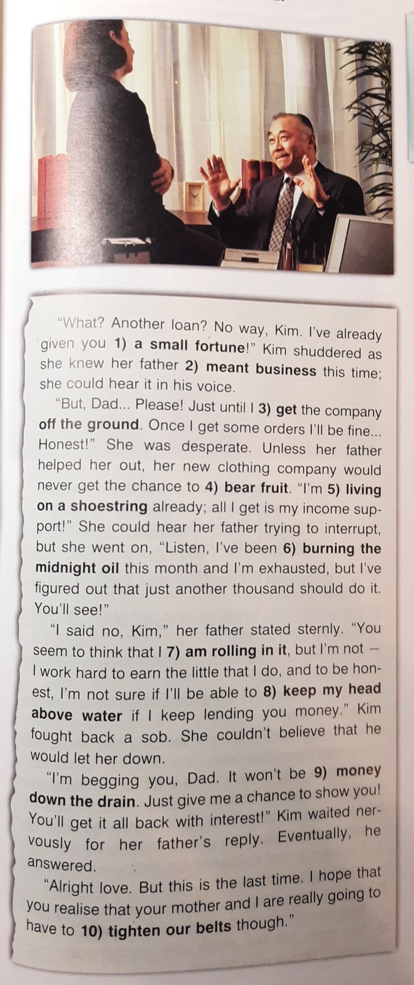
WRITE THE TRANSLATION OF THE EXTRACT

